# Staff login

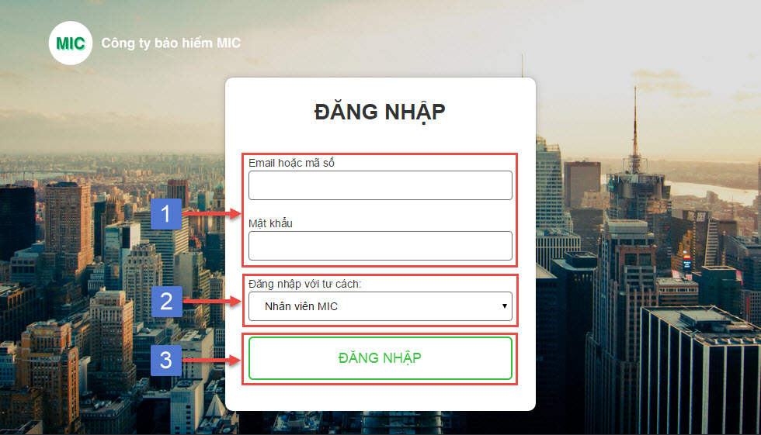

## Staff login page

|  |  |
| --- | --- |
| **Step** | **Description** |
| 1 | Input email or code and password to login |
| 2 | Select role is “Nhân viên MIC” |
| 3 | Click “ĐĂNG NHẬP” button |

## Staff login step

# Staff manage customer

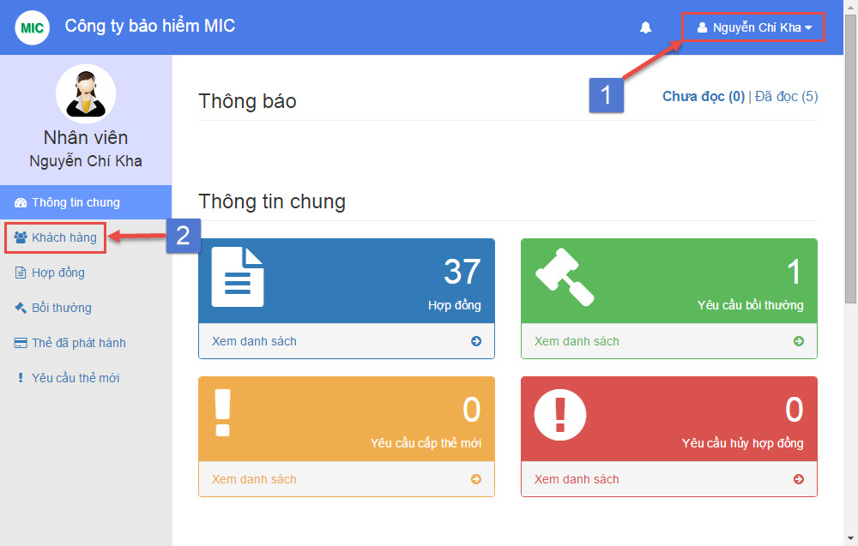

## Staff dashboard

|  |  |
| --- | --- |
| **Step** | **Description** |
| 1 | Login with “Staff” role |
| 2 | Select menu “Khách hàng” from navigation bar |

## Staff manage customer step

# Staff create new customer

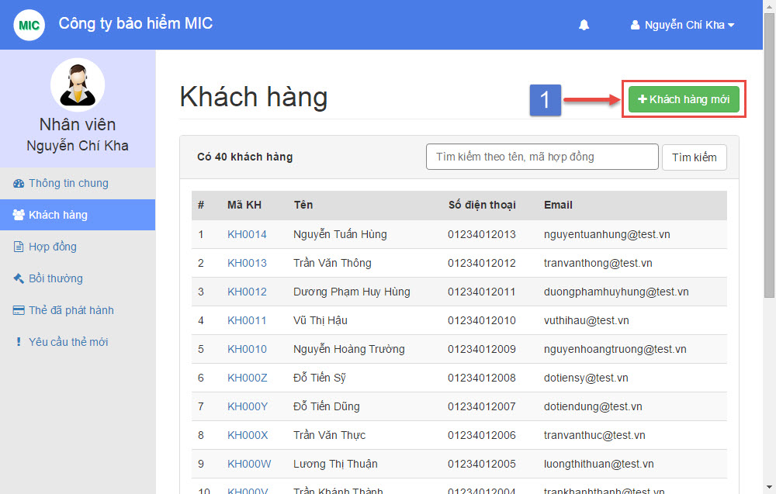

## Staff manage customer page

|  |  |
| --- | --- |
| **Step** | **Description** |
| 1 | Click on button “Khách hàng mới” |

## Staff create new customer step

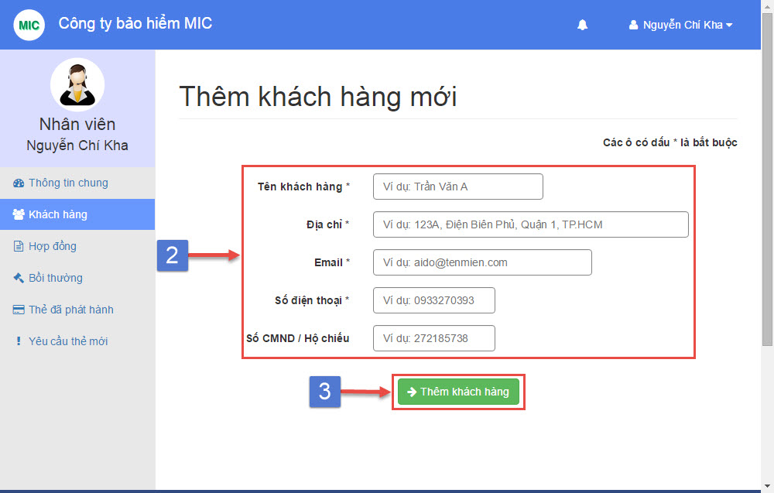

## Staff create new customer page

|  |  |
| --- | --- |
| **Step** | **Description** |
| 2 | Fill customer name, address, email, phone number (required)  Fill customer ID number (optional) |
| 3 | Click “Thêm khách hàng” button |

## Staff create new customer step

# Staff view customer detail

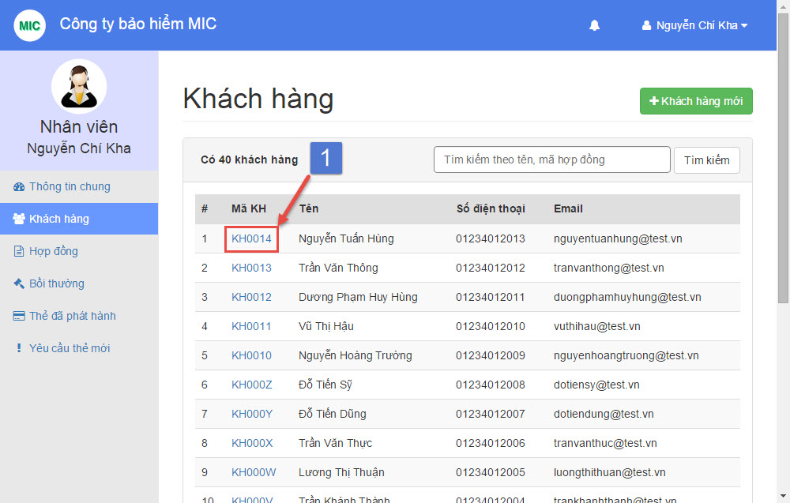

## Staff manage customer page

|  |  |
| --- | --- |
| **Step** | **Description** |
| 1 | Click on view customer detail link |

## Staff view customer detail step

# Staff edit customer information

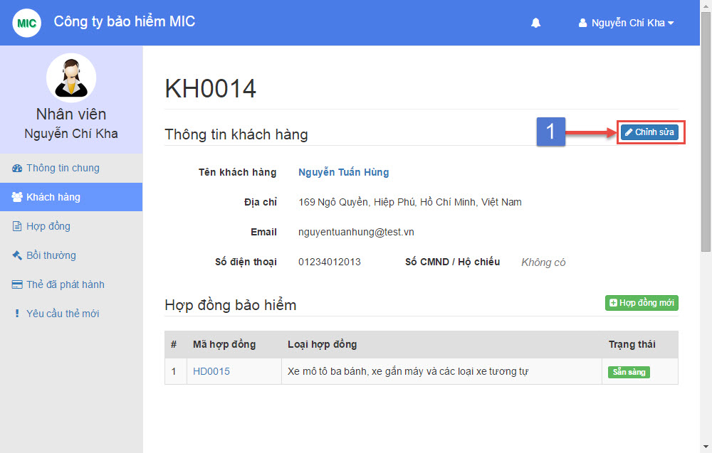

## Staff view customer detail page

|  |  |
| --- | --- |
| **Step** | **Description** |
| 1 | Click on button “Chỉnh sửa” |

## Staff edit customer information step

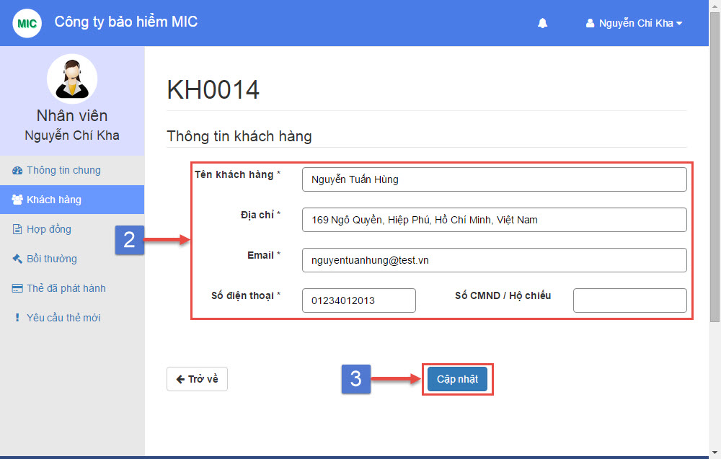

## Staff edit customer information page

|  |  |
| --- | --- |
| **Step** | **Description** |
| 2 | Fill customer name, address, email, phone number (required)  Fill customer ID number (optional) |
| 3 | Click “Cập nhật” button |

## Staff edit customer information step

# Staff manage contract

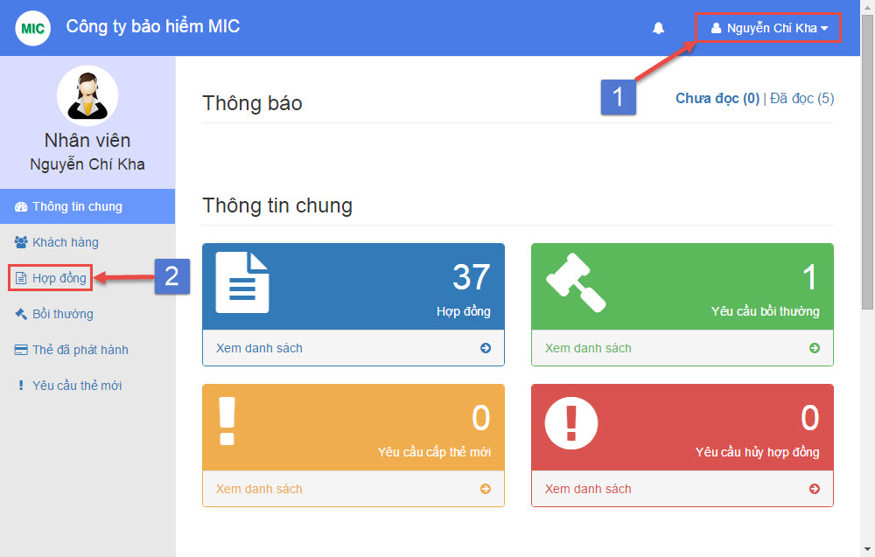

## Staff dashboard

|  |  |
| --- | --- |
| **Step** | **Description** |
| 1 | Login with “Staff” role |
| 2 | Select menu “Hợp đồng” from navigation bar |

## Staff manage contract step

# Staff create new contract

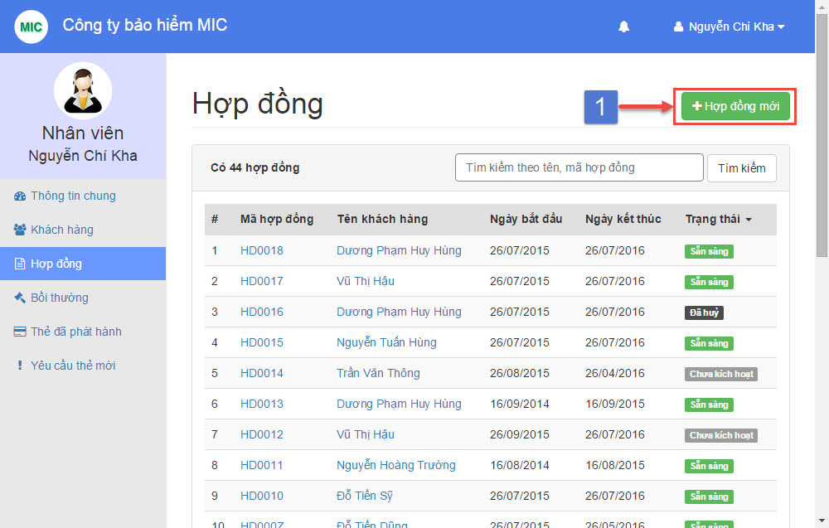

## Staff manage contract page

|  |  |
| --- | --- |
| **Step** | **Description** |
| 1 | Click on button “Hợp đồng mới” |

## Staff create contract step

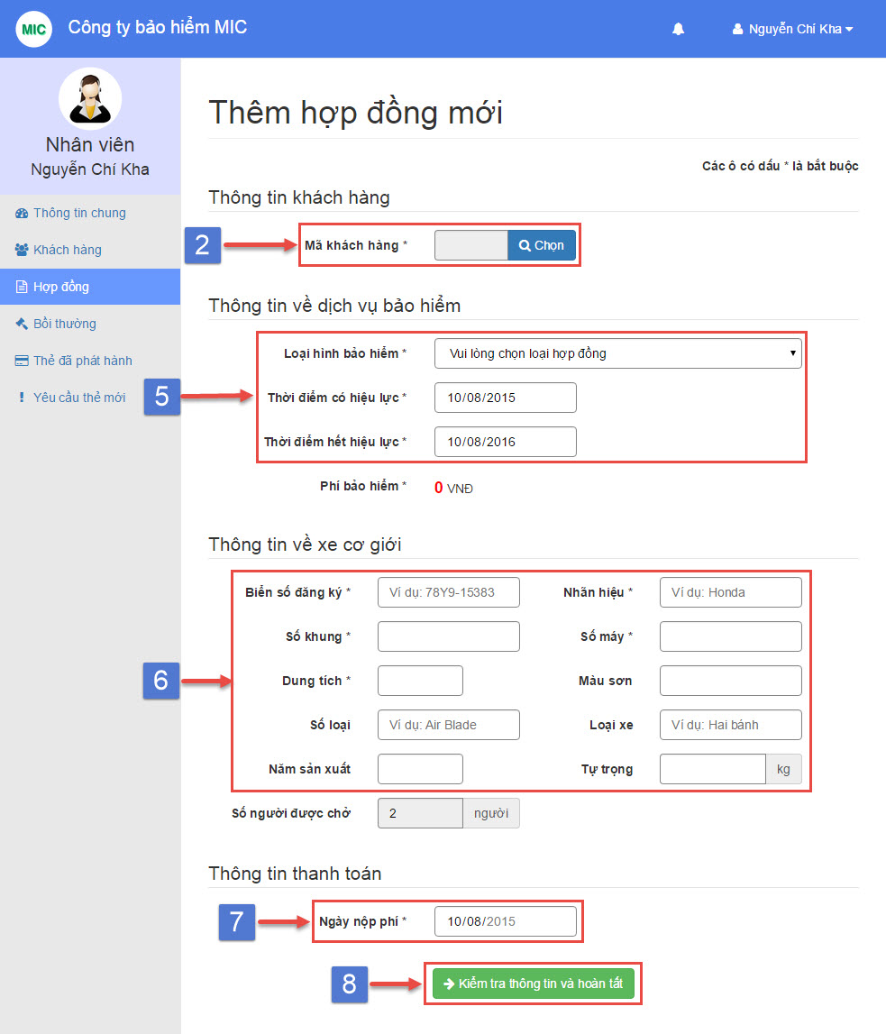

## Staff create new contract page

|  |  |
| --- | --- |
| **Step** | **Description** |
| 2 | Click “Chọn” button |

## Staff create new contract step

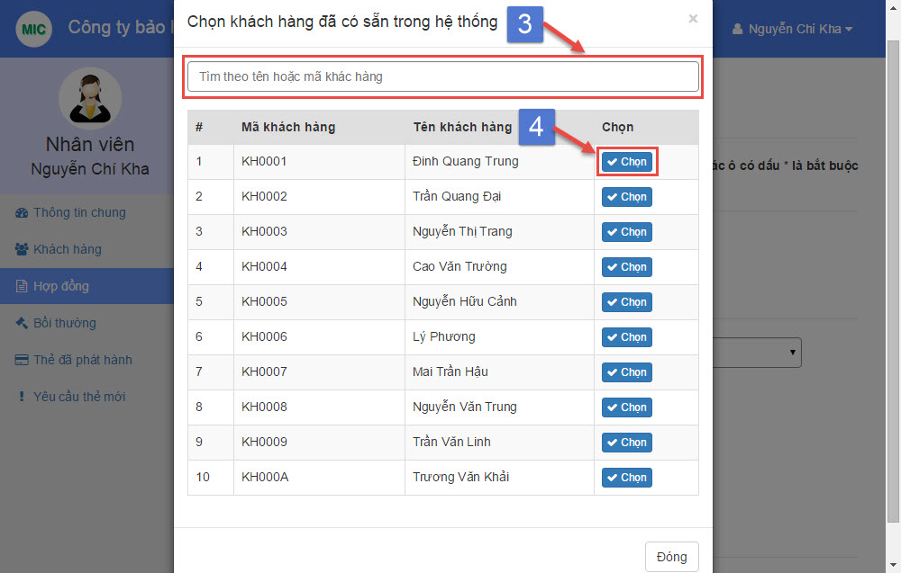

## Staff select customer popup

|  |  |
| --- | --- |
| **Step** | **Description** |
| 3 | Search customer by name or code |
| 4 | Click “Chọn” button |

## Staff select customer step



## Staff create new contract page

|  |  |
| --- | --- |
| **Step** | **Description** |
| 5 | Select contract type in “Loại hình bảo hiểm” dropdown list (required)  Choose “Thời điểm có hiệu lực” the start date of this contract (required)  Choose “Thời điểm hết hiệu lực” the end date of this contract (required) |
| 6 | Fill vechile plate, brand, engine, chassis, capacity (required)  Fill color, model code, vehicle type, year of manufacture, weight (optional) |
| 7 | Choose “Ngày nộp phí” the paid date of this contract (required) |
| 8 | Click “Kiểm tra thông tin và hoàn tất” button |

## Staff create new contract step

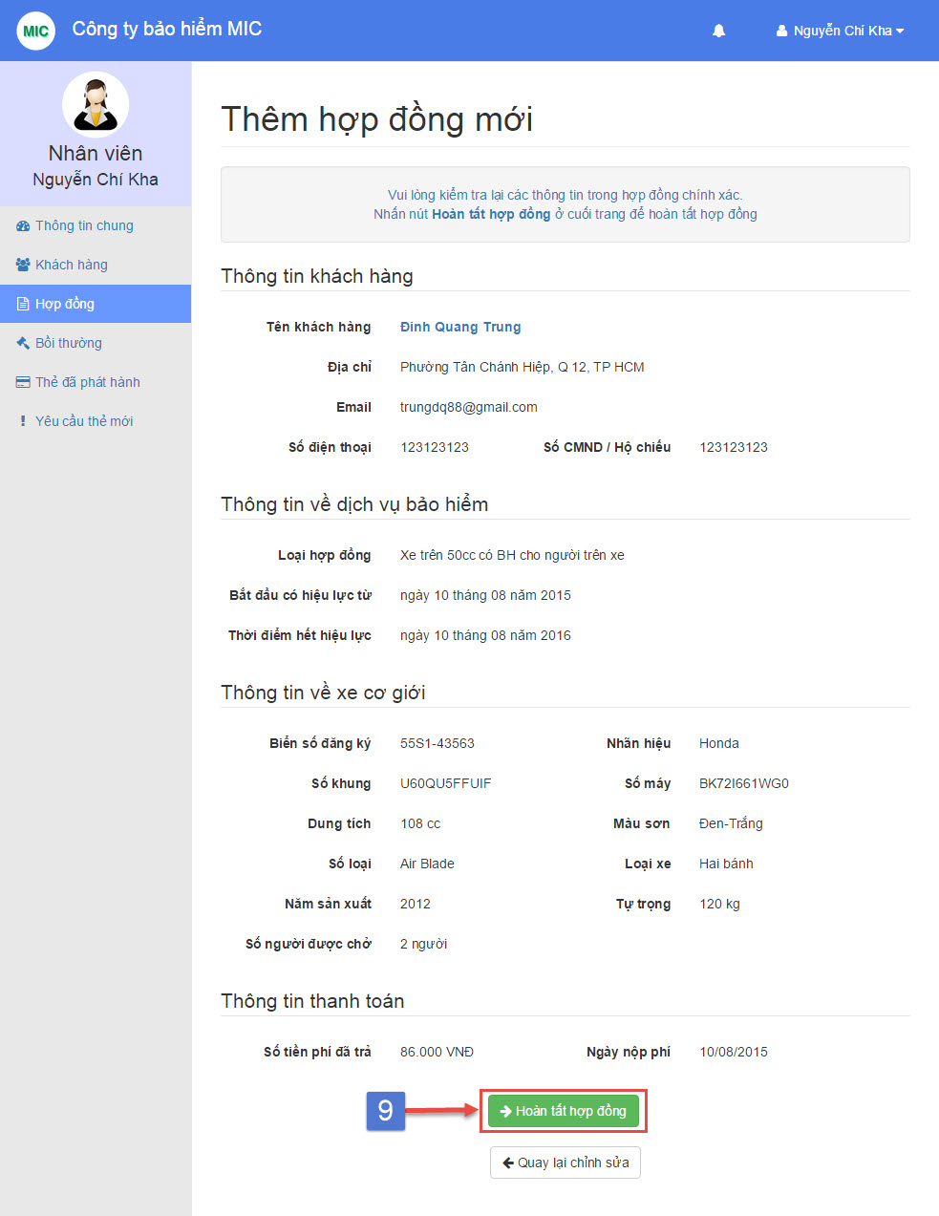

## Staff create new contract preview page

|  |  |
| --- | --- |
| **Step** | **Description** |
| 9 | Click “Hoàn tất hợp đồng” button |

## Staff create new contract step

# Staff view contract detail

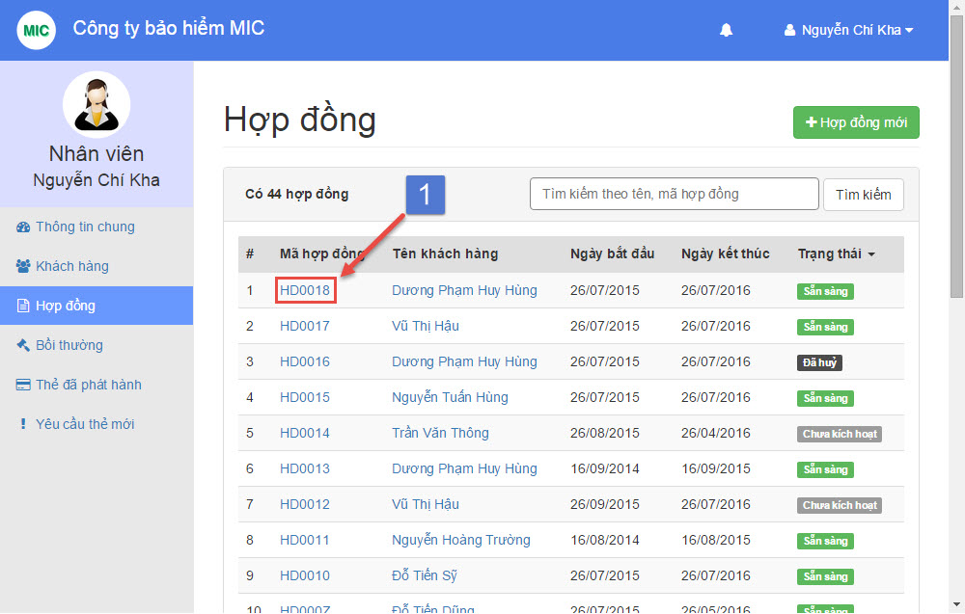

## Staff manage contract page

|  |  |
| --- | --- |
| **Step** | **Description** |
| 1 | Click on view contract detail link |

## Staff view contract detail step

# Staff complete payment

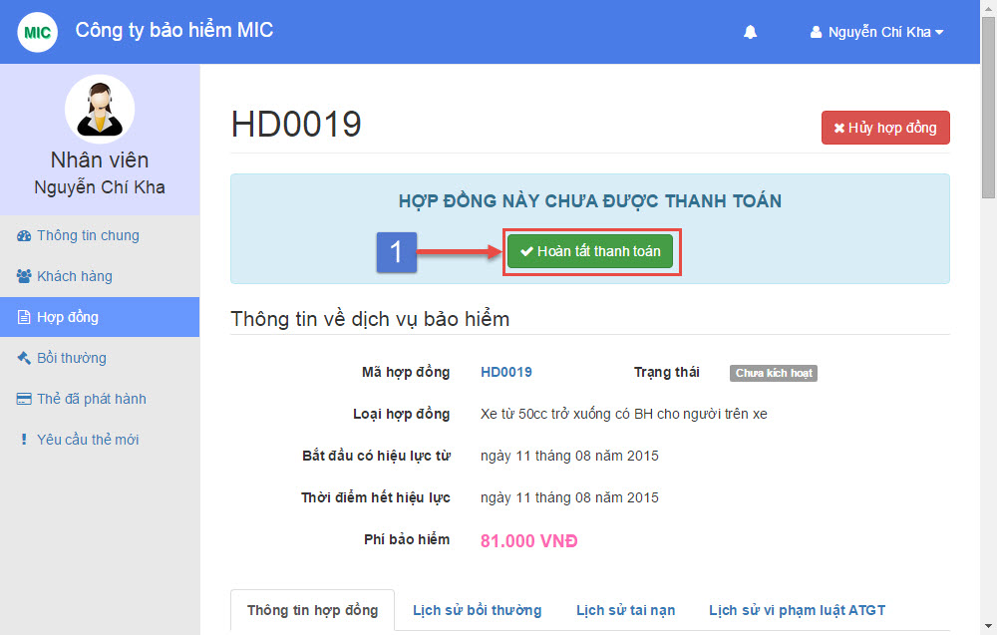

## Staff complete payment page

|  |  |
| --- | --- |
| **Step** | **Description** |
| 1 | Click “Hoàn tất thanh toán” button |

## Staff complete payment step

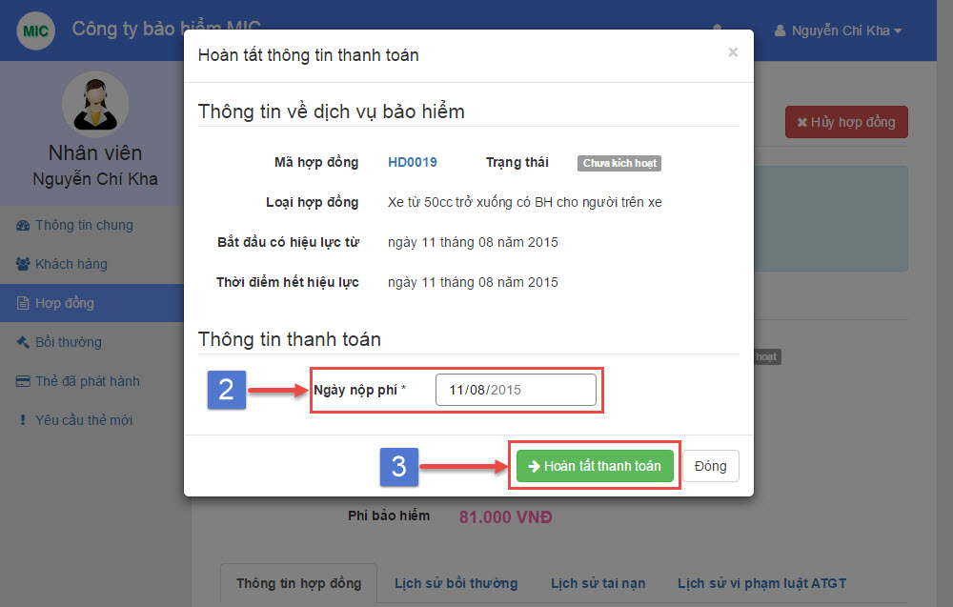

## Staff complete payment popup

|  |  |
| --- | --- |
| **Step** | **Description** |
| 2 | Choose “Ngày nộp phí” the payment paid date (required) |
| 3 | Click “Hoàn tất thanh toán” button |

## Staff complete payment step

# Staff renew contract

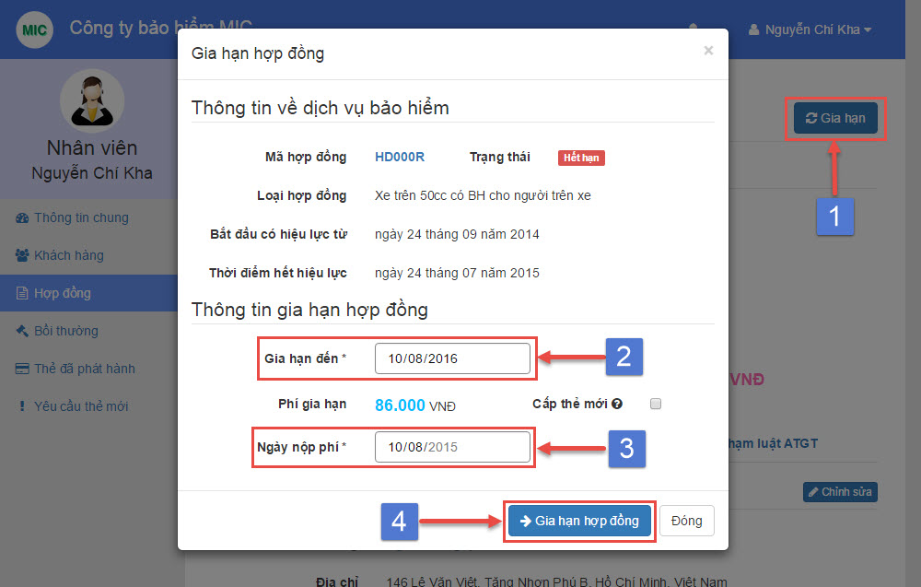

## Staff renew contract popup

|  |  |
| --- | --- |
| **Step** | **Description** |
| 1 | Click “Gia hạn” button |
| 2 | Choose “Gia hạn đến” the contract new expired date (required) |
| 3 | Choose “Ngày nộp phí” the contract paid date (required) |
| 4 | Click “Gia hạn hợp đồng” button |

## Staff renew contract step

# Staff resolve cancel request

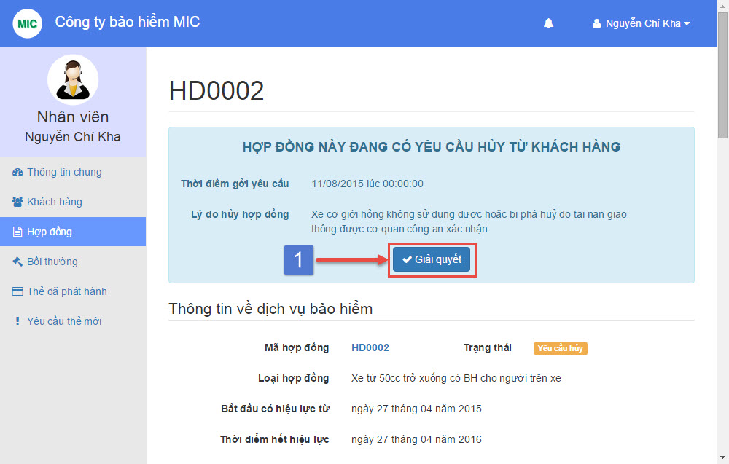

## Staff resolve cancel request page

|  |  |
| --- | --- |
| **Step** | **Description** |
| 1 | Click “Giải quyết” button |

## Staff resolve cancel request step

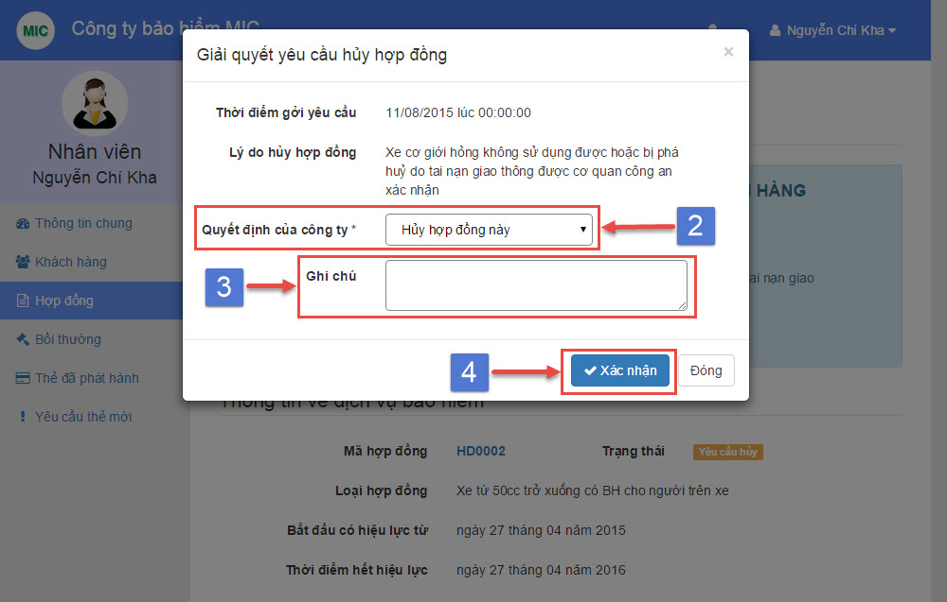

## Staff resolve cancel request popup

|  |  |
| --- | --- |
| **Step** | **Description** |
| 2 | Choose “Quyết định của công ty” (required) |
| 3 | Input “Ghi chú” if company decision is cancel this contract (optional) |
| 4 | Click “Xác nhận” button |

## Staff resolve cancel request step

# Staff cancel contract

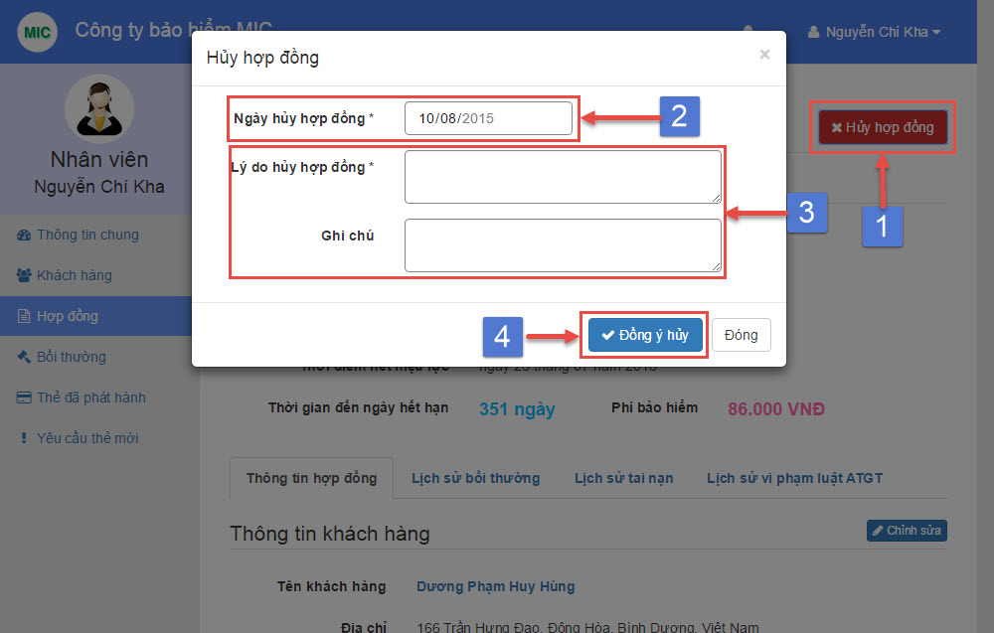

## Staff cancel contract popup

|  |  |
| --- | --- |
| **Step** | **Description** |
| 1 | Click “Hủy hợp đồng” button |
| 2 | Choose “Ngày hủy hợp đồng” the contract cancel date (required) |
| 3 | Fill “Lý do hủy hợp đồng” the contract cancel reason (required)  Fill “Ghi chú” the contract cancel note (optional) |
| 4 | Click “Đồng ý hủy” button |

## Staff cancel contract step

# Staff create new payment

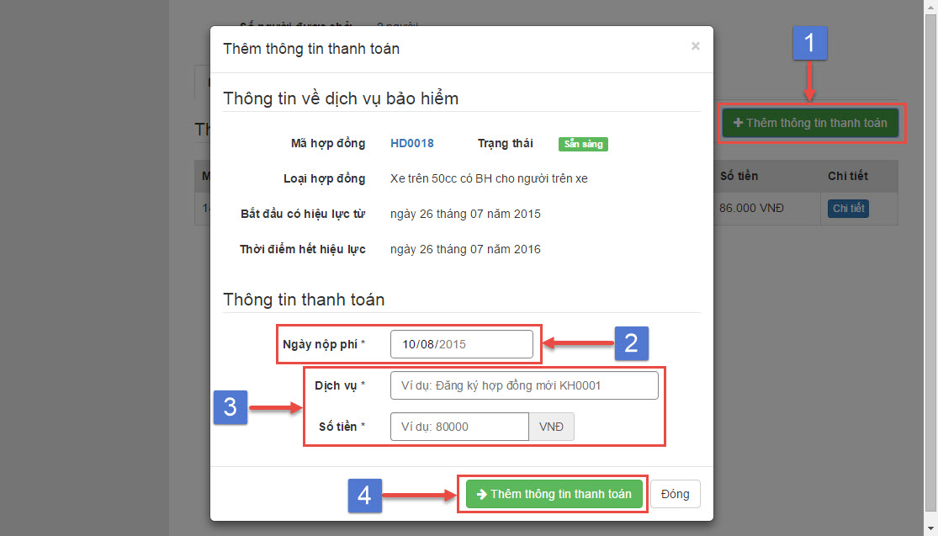

## Staff create new payment popup

|  |  |
| --- | --- |
| **Step** | **Description** |
| 1 | Click “Thêm thông tin thanh toán” button |
| 2 | Choose “Ngày nộp phí” the payment paid date (required) |
| 3 | Fill “Dịch vụ” the payment service (required)  Fill “Số tiền” the payment amount (required) |
| 4 | Click “Thêm thông tin thanh toán” button |

## Staff create new payment step

# Staff view payment detali

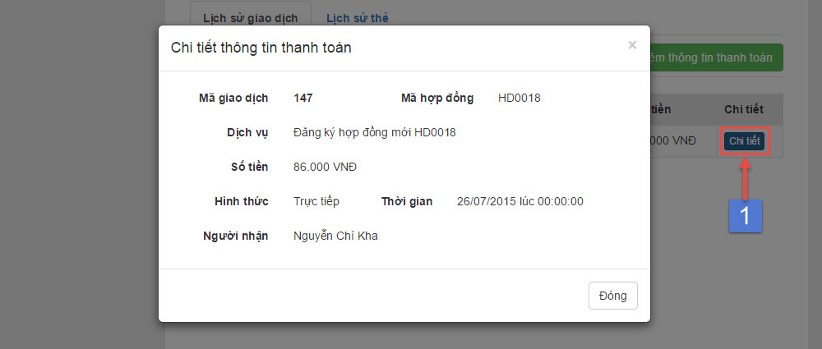

## Staff view payment detail popup

|  |  |
| --- | --- |
| **Step** | **Description** |
| 1 | Click “Chi tiết” button |

## Staff view payment detail step

# Staff update contract information

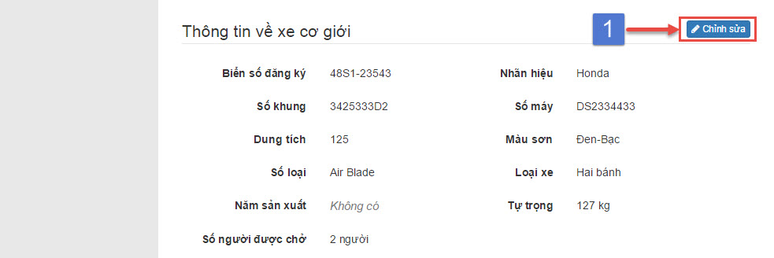

## Staff update contract information page

|  |  |
| --- | --- |
| **Step** | **Description** |
| 1 | Click “Chỉnh sửa” button |

## Staff update contract information step

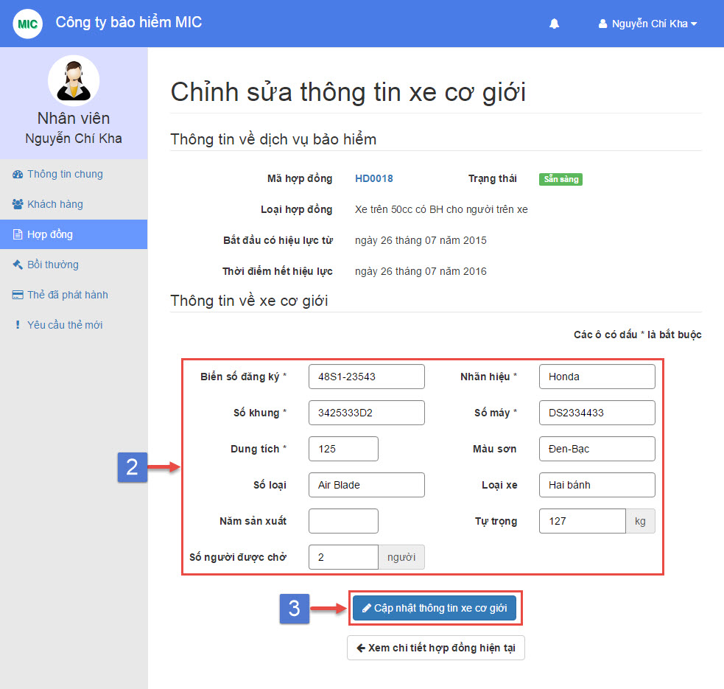

## Staff update contract information page

|  |  |
| --- | --- |
| **Step** | **Description** |
| 2 | Fill vechile plate, brand, engine, chassis, capacity (required)  Fill color, model code, vehicle type, year of manufacture, weight, seat capacity (optional) |
| 3 | Click “Cập nhật thông tin xe cơ giới” button |

## Staff update contract information step

# Staff create new accident

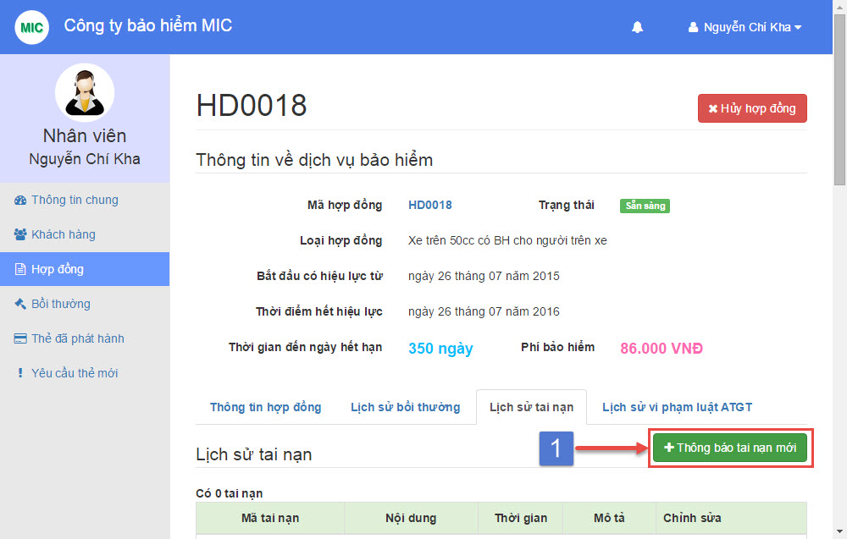

## Staff create new accident

|  |  |
| --- | --- |
| **Step** | **Description** |
| 1 | Click “Thông báo tai nạn mới” button |

## Staff create new accident step

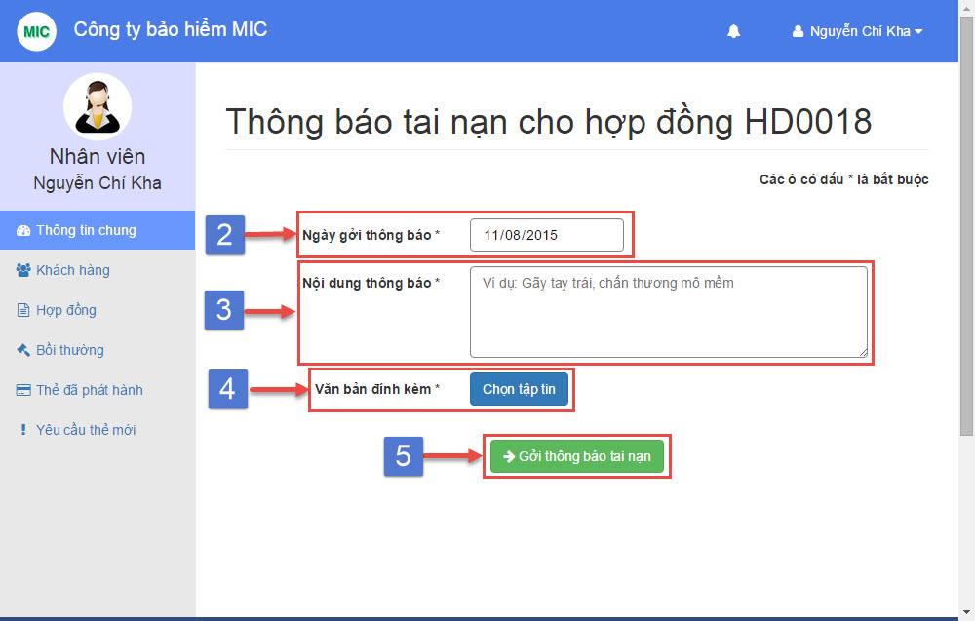

## Staff create new accident page

|  |  |
| --- | --- |
| **Step** | **Description** |
| 2 | Choose “ Ngày gởi thông báo” the accident created date (required) |
| 3 | Input “Nội dung thông báo” the accident title (required) |
| 4 | Choose attachment file and upload to the system (required) |
| 5 | Click “Gởi thông báo tai nạn” button |

## Staff create new accident step

# Staff create new punishment

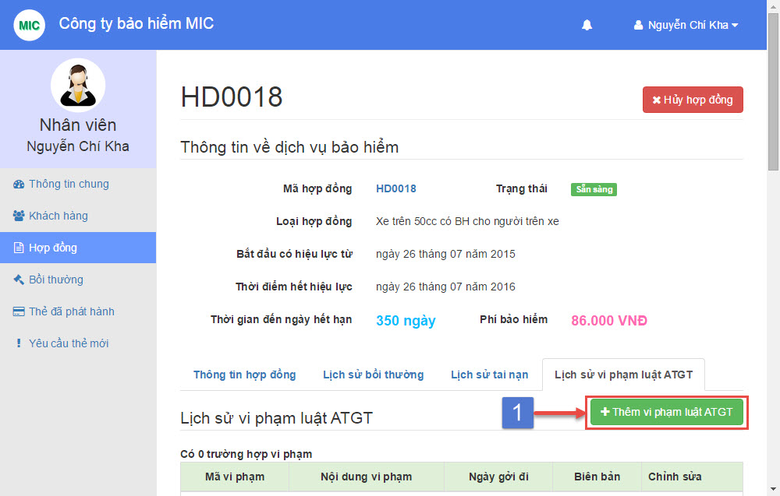

## Staff create new punishment

|  |  |
| --- | --- |
| **Step** | **Description** |
| 1 | Click “Thêm vi phạm luật ATGT” button |

## Staff create new punishment step

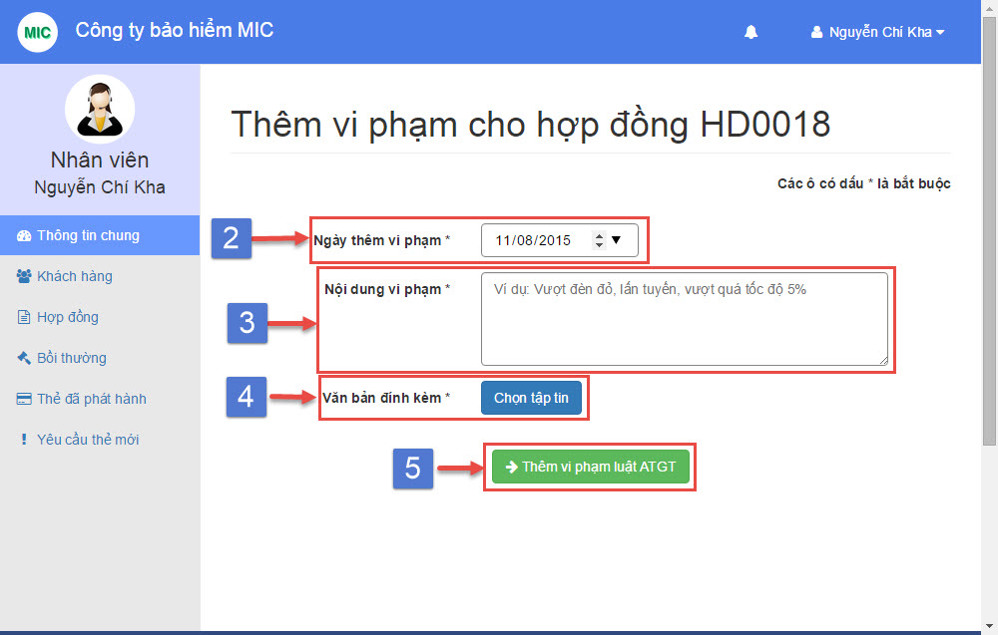

## Staff create new punishment page

|  |  |
| --- | --- |
| **Step** | **Description** |
| 2 | Choose “ Ngày gởi thông báo” the punishment created date (required) |
| 3 | Input “Nội dung thông báo” the punishment title (required) |
| 4 | Choose attachment file and upload to the system (required) |
| 5 | Click “Thêm vi phạm luật ATGT” button |

## Staff create new punishment step

# Staff manage compensation

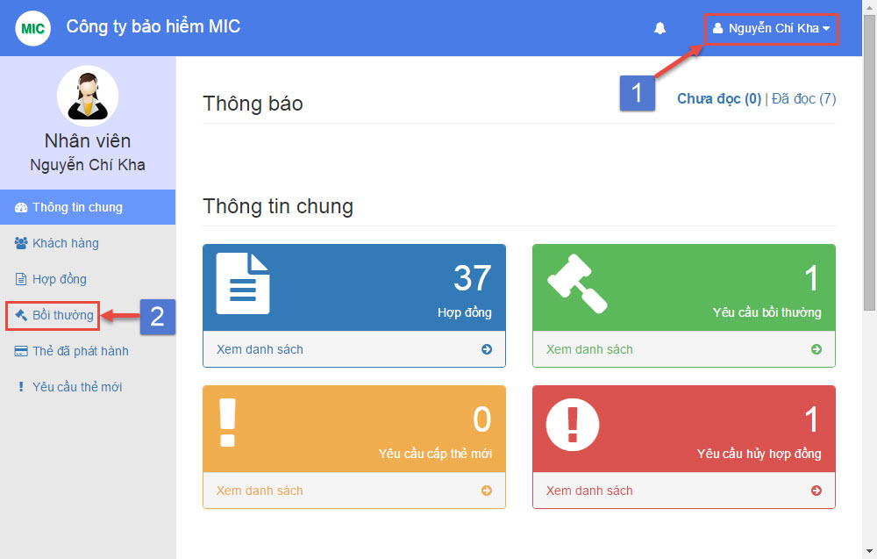

## Staff dashboard

|  |  |
| --- | --- |
| **Step** | **Description** |
| 1 | Login with “Staff” role |
| 2 | Select menu “Bồi thường” from navigation bar |

## Staff manage compensation step

# Staff create new compensation

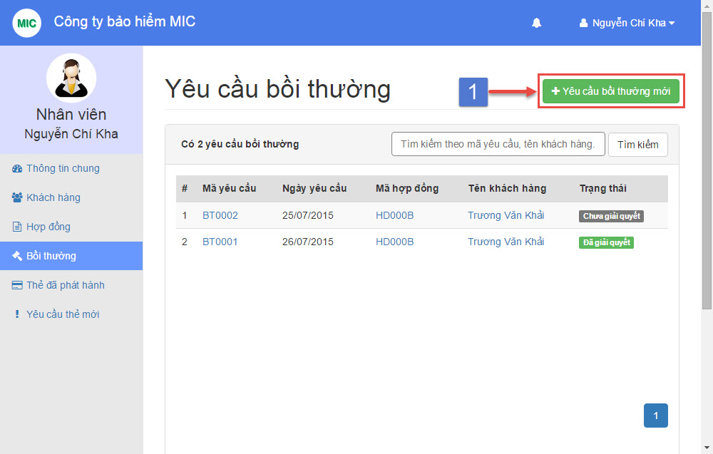

## Staff manage compensation page

|  |  |
| --- | --- |
| **Step** | **Description** |
| 1 | Click on button “Yêu cầu bồi thường mới” |

## Staff create new compensation step

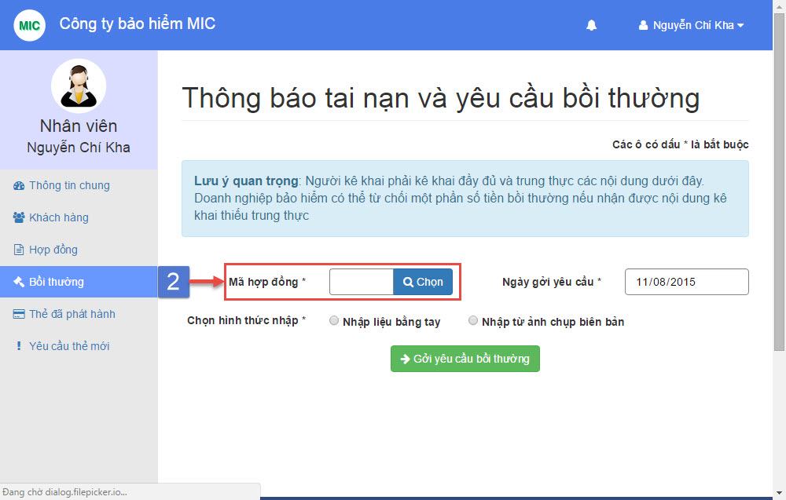

## Staff create new compensation page

|  |  |
| --- | --- |
| **Step** | **Description** |
| 2 | Click “Chọn” button |

## Staff create new compensation step

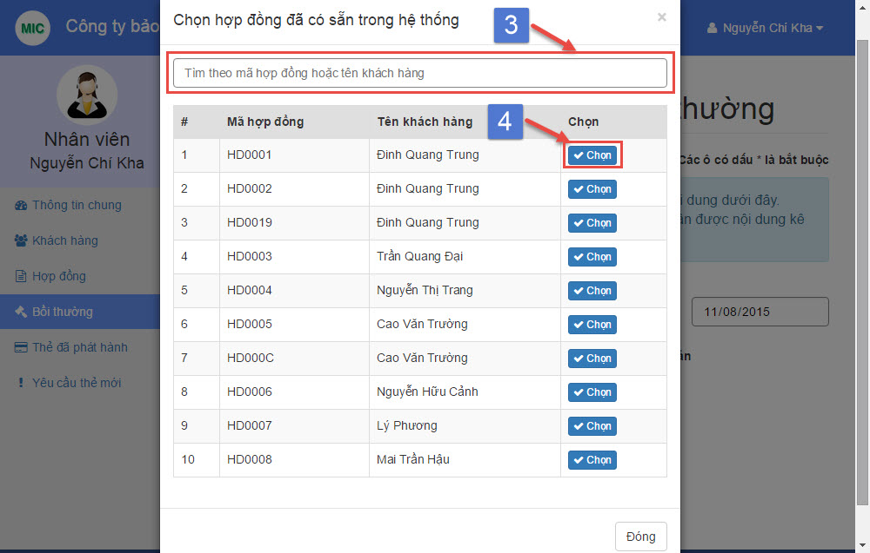

## Staff select contract popup

|  |  |
| --- | --- |
| **Step** | **Description** |
| 3 | Search contract by contract code or customer name |
| 4 | Click “Chọn” button |

## Staff select contract step

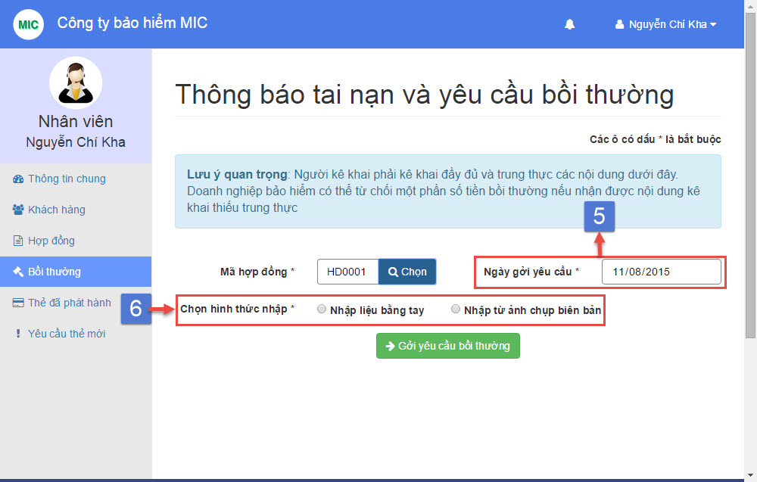

## Staff create new compensation page

|  |  |
| --- | --- |
| **Step** | **Description** |
| 5 | Choose “Ngày gởi yêu cầu” the compensation created date (required) |
| 6 | Select “Chọn hình thức nhập” from two option (required) |

## Staff create new compensation step

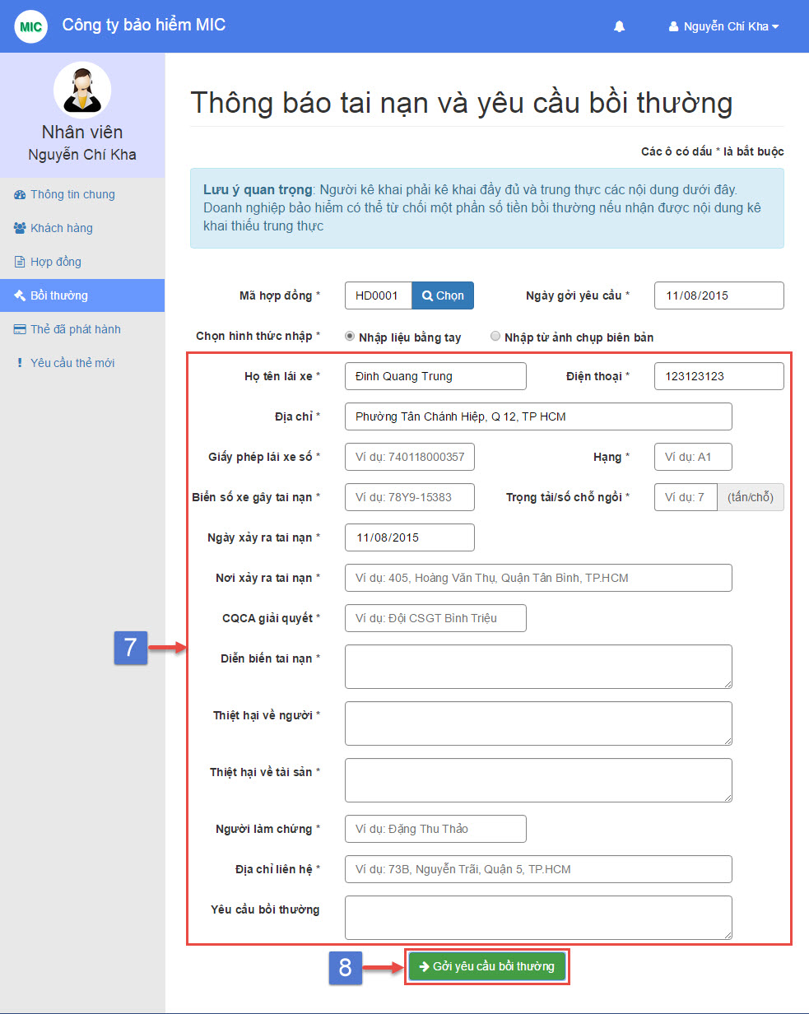

## Staff create new compensation page

|  |  |
| --- | --- |
| **Step** | **Description** |
| 7 | Fill driver name, phone, address, license number, license type, vehicle plate, seat capacity, accident date, accident place, control deparment, description, human damage, asset damage, observer name, observer address (required)  Fill compensation request note (optional) |
| 8 | Click “Gởi yêu cầu bồi thường” button |

## Staff create new compensation step

# Staff view compensation detail

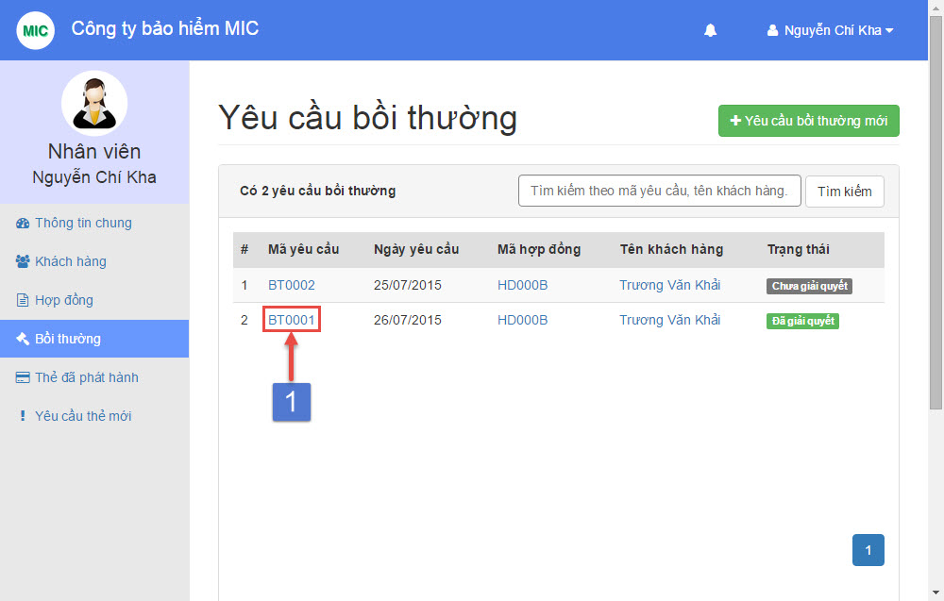

## Staff manage compensation page

|  |  |
| --- | --- |
| **Step** | **Description** |
| 1 | Click on view compensation detail link |

## Staff view compensation detail step

# Staff compensation cancel request

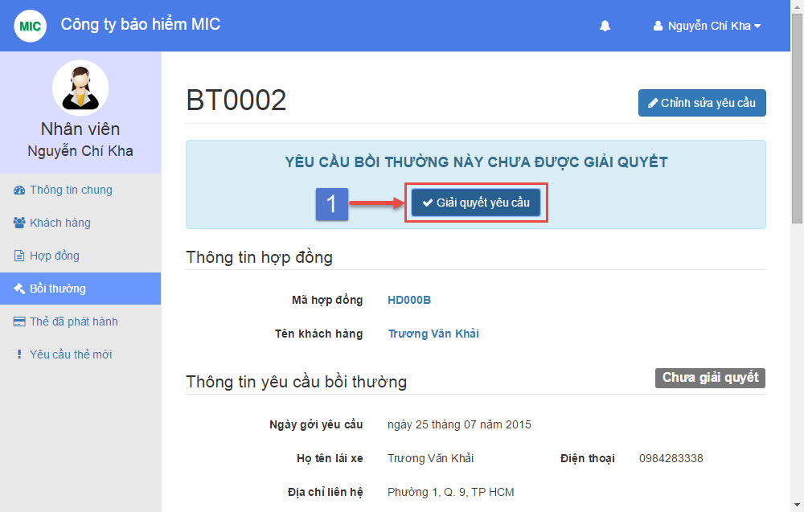

## Staff resolve compensation request page

|  |  |
| --- | --- |
| **Step** | **Description** |
| 1 | Click “Giải quyết yêu cầu” button |

## Staff resolve compensation request step

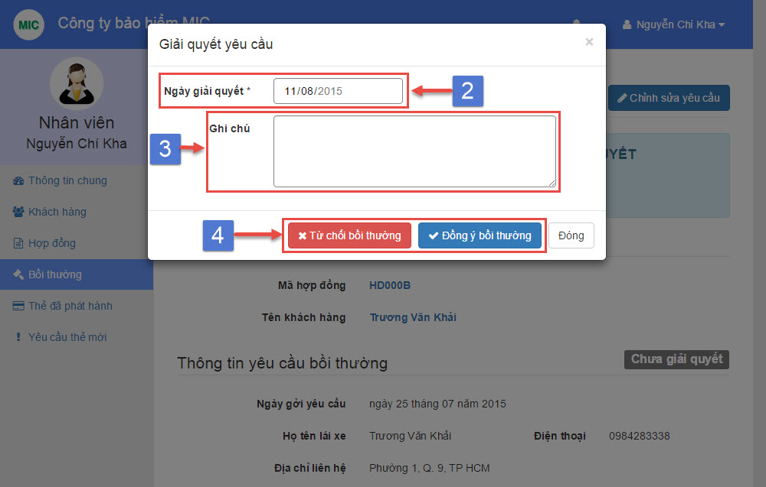

## Staff resolve compensation request popup

|  |  |
| --- | --- |
| **Step** | **Description** |
| 2 | Choose “Ngày giải quyết” the compensation resolved date (required) |
| 3 | Input “Ghi chú” the compensation resolve note (optional) |
| 4 | Select one from two option by click “Từ chối bồi thường” or “Đồng ý bồi thường” button |

## Staff resolve compensation request step